**Slime**

The work was first inspired by a slime moving very slowly in video games. To represent the movement of it, I used glissandos in a small range. Later in the music, I decided to explore a dry and crispy sound to contrast with the slimy section. The texture of the work is subtle, but irritated by fragments of noise materials alongside the texture. The structure of the work is fugue-like. It begins with a single line in the alto flute and gradually spreads the pitches and adds new colours. Also, the motif is stated in a variety of ways, such as single line and stretto. Furthermore, episodes are usually timbre based, for example bars 24 – 28. A contrast of timbre begins in the transition after the climax of the slimy section (bar 53) where a new section with a dryier texture is introduced in bar 58.

The pitch material of the work is based on a motif, A♭, G, A, B♭, A, A♭, G♭, G. The motif is confined within a small range for exploring more microtonal material by slow glissandos. However, the main focus in the work is using different timbres to introduce the motif. For example, different levels of air pressure on wind instruments and string instruments are played in different areas, such as *sul ponticello*, *molto sul ponticello* or ordinary. Besides that, pizzicato and pitched key clicks on wind instruments are also applied to introduce the motif. Additionally, all changes on timbre and pitch are slow, to represent the slimy movement.

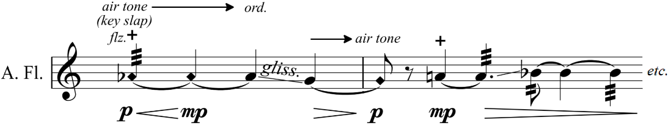

Figure 1: Alto Flute plays different air pressures and key slaps/key clicks in bars 19-20

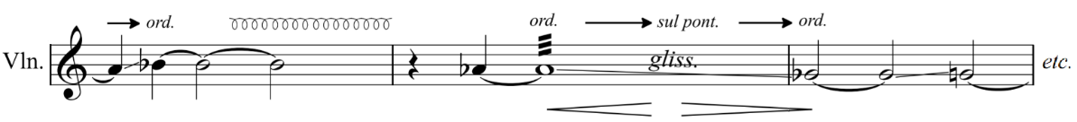

*Figure 2: Violin plays different areas in bars 9-11*

Moreover, the imitation of sounds between instruments is significant in the work. In bars 17 – 19, alto flute, violin and bass clarinet play key clicks and left hand snaps to

match/imitate eachother’s sounds. This idea becomes more developed in bar 24 and bars 29 – 31, but string instruments switch to *col legno* on all strings behind the bridge.

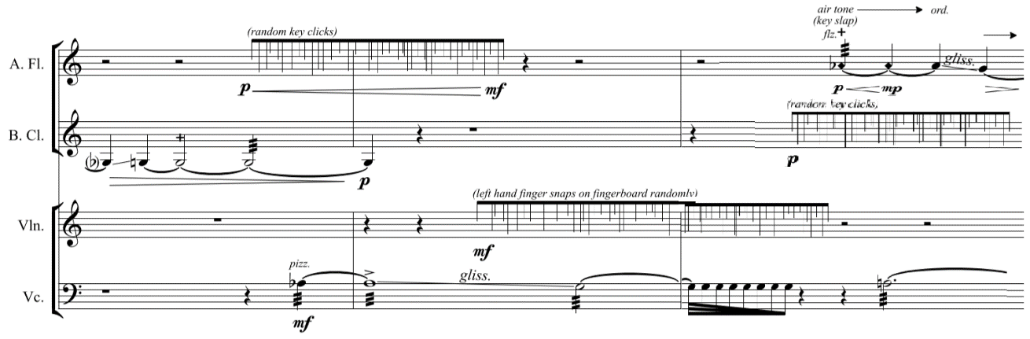  
*Figure 3: sounds matching between alto flute, bass clarinet and violin in bars 17-19*

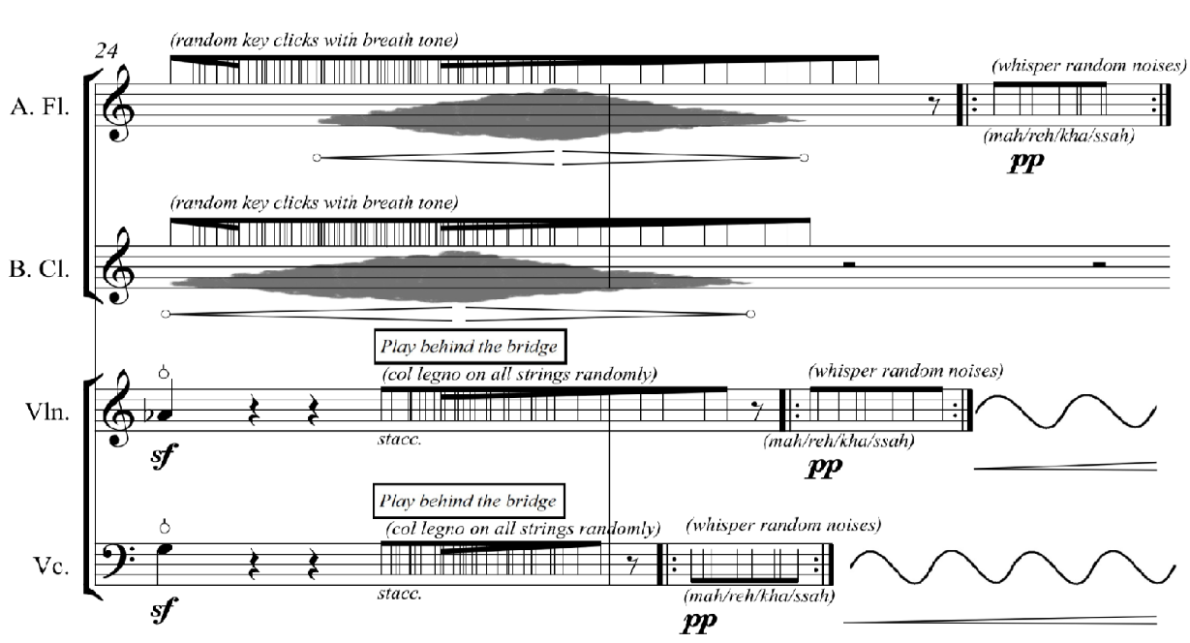

*Figure 4: developed ideas in bars 17-19*

Apart from that, the stretto in bars 32 – 38 also demonstrates the sound matching between the instruments. It is proceeded by a single line motif in alto flute accompanied by bass clarinet, violin and cello playing key clicks and *col legno* on all strings behind the bridge.

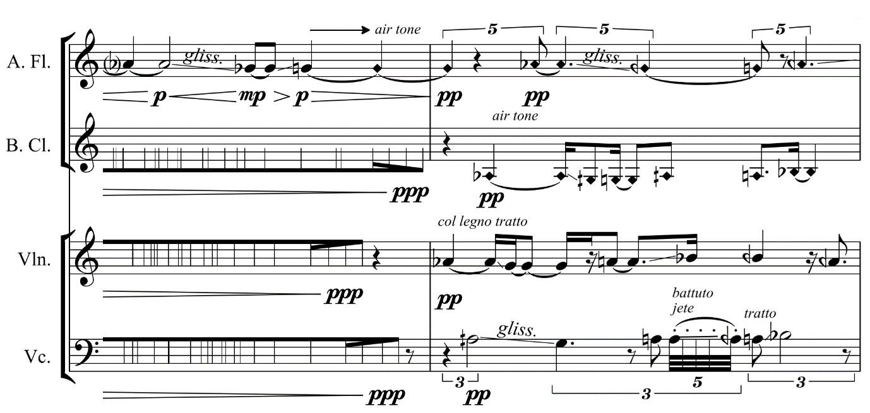

*Figure 5: sounds matching with all instruments in bars 31-32*

Additionally, I experimented with an extended technique on cello, tremolo with repeating pizzicato. This is a technique coming from plucked string instruments, such as guitar and mandolin. Then, the technique is tranferred into the cello, to create a different timbre.

*Figure 6: cello plays tremolo with repeating pizzicato in bars 17-20*